
Sigma Journal of Mathematical and Statistical Sciences (SJMSS)
Published by Altech Press • https://sjmss.altechpress.com
Vol. X, No. X (20XX), pp. XX–XX • ISSN: XXXX–XXXX • https://doi.org/10.XXXXX/sjmss.20XX.XXXX
Research Article
Title of the Manuscript: Concise and Informative, Written in Title Case (Maximum 20 Words)
First A. Author^{1,*}, Second B. Author² and Third C. Author^{1,2}
¹ Department of Mathematics, College of Science, University Name, City, Country
² Department of Statistics, Faculty of Arts and Sciences, University Name, City, Country
* Corresponding author: author@university.edu • ORCID: 0000-0000-0000-0000
Received: DD Month 20XX • Revised: DD Month 20XX • Accepted: DD Month 20XX • Published online: DD Month 20XX
ABSTRACT
The abstract should be a single paragraph of 150–250 words. It must state concisely the purpose of the research, the principal methods used, the main results obtained, and the major conclusions. The abstract must be self-contained: do not include citations, displayed equations, footnotes, or undefined abbreviations. Replace this placeholder text with your own abstract, keeping the formatting of this template (Times New Roman, 11 pt, justified, single spacing). The abstract is often the only part of the paper that is read, so it should be clear, accurate, and informative.
Keywords: first keyword; second keyword; third keyword; fourth keyword; fifth keyword (4–6 keywords, separated by semicolons)
MSC 2020: 35R11; 65M06; 65M12 (2–4 classification codes)

1. Introduction
The introduction should state the scientific context of the work, review the relevant literature with numbered citations in square brackets [1], [2, 3], [4–6], identify the gap that the paper addresses, and clearly state the objectives and contributions of the study. Citations are numbered in order of first appearance in the text. All paragraphs of the body text are set in Times New Roman, 11 pt, justified, with 1.15 line spacing and 6 pt spacing after each paragraph; paragraphs are not indented.
Inline mathematical symbols such as $0<α≤1$ and $u\left(t,x\right)∈C^{2}\left(Ω\right)$ must be created with the native Microsoft Word equation editor (OMML), exactly as in this template. Equations inserted as images, MathType objects, or plain text will be returned to the authors. The last paragraph of the introduction should outline the organization of the paper.

2. Preliminaries
This section presents the definitions, notation, and auxiliary results used throughout the paper. Display equations are centered, with the equation number in parentheses right-aligned on the same line, and are cited in the text as Eq. (1) or simply (1).
Definition 2.1. The Caputo fractional derivative of order $α$ of a function $u\left(t,x\right)$ with respect to $t$ is defined as
$D_{t}^{α}u\left(t,x\right)=\frac{1}{Γ\left(n-α\right)}\int_{0}^{t}{{\left(t-s\right)}^{n-α-1}} \frac{∂^{n}u\left(s,x\right)}{∂s^{n}} ds, n-1<α<n,$ (1)
where $Γ\left(⋅\right)$ denotes the Gamma function. As a model problem, consider the fractional-order partial differential equation
$u_{tt}\left(t,x\right)+D_{t}^{α}u\left(t,x\right)+u\left(t,x\right)-k u_{txx}\left(t,x\right)-u_{xx}\left(t,x\right)=f\left(t,x\right),$ (2)
subject to appropriate initial and boundary conditions, where $k>0$ and $0<α≤1$. Define all symbols at their first use and keep the notation consistent throughout the manuscript.

3. Main Results

3.1. Theorem environments
Definitions, Lemmas, Theorems, Propositions, and Corollaries are numbered within sections (e.g., Theorem 3.1, Lemma 3.2). The label is set in bold and the statement in italic, as shown below. Proofs begin with the word “Proof.” in bold italic and end with the tombstone symbol ∎.
Theorem 3.1. Suppose that the stability condition
$1-2\left(\frac{k}{h^{2}τ}-\frac{1}{τ^{2}}+\frac{1}{h^{2}}\right)-\frac{k w_{1}}{Γ\left(2-α\right) τ^{α}}>0$ (3)
holds. Then the difference scheme (2) is stable, and its solution satisfies the estimate $∥u^{k}∥≤C∥u^{0}∥$ for some constant $C>0$ independent of $h$ and $τ$.
Proof. The proof is written here in regular body text. Intermediate steps may include displayed equations, which continue the consecutive equation numbering of the paper. The end of the proof is marked with the tombstone symbol, right-aligned on the final line. ∎

4. Numerical Results and Discussion
Tables and figures are inserted in the text near their first citation, and every table and figure must be cited (e.g., Table 1, Figure 1). Table captions are placed above the table; figure captions are placed below the figure. Tables use horizontal rules only, with a shaded header row and no vertical lines, as illustrated in Table 1.
Table 1. Comparison of the exact and approximate solutions for various parameter values.
N = M | α | Exact solution | Approximate solution | Absolute error
50 | 0.99 | 2.0000 | 2.0004 | 4.00 × 10⁻⁴
100 | 0.50 | 2.0000 | 1.9992 | 8.00 × 10⁻⁴
200 | 0.50 | 2.0000 | 2.0000 | 0.00
400 | 0.01 | 2.0000 | 1.9994 | 6.00 × 10⁻⁴

The numerical results should be discussed critically: comment on accuracy, convergence behavior, and comparison with existing methods. Figures must be legible at print size, with a minimum resolution of 300 dpi (PNG, TIFF, or EPS); axis labels, legends, and fonts should be clearly readable, as illustrated in Figure 1.
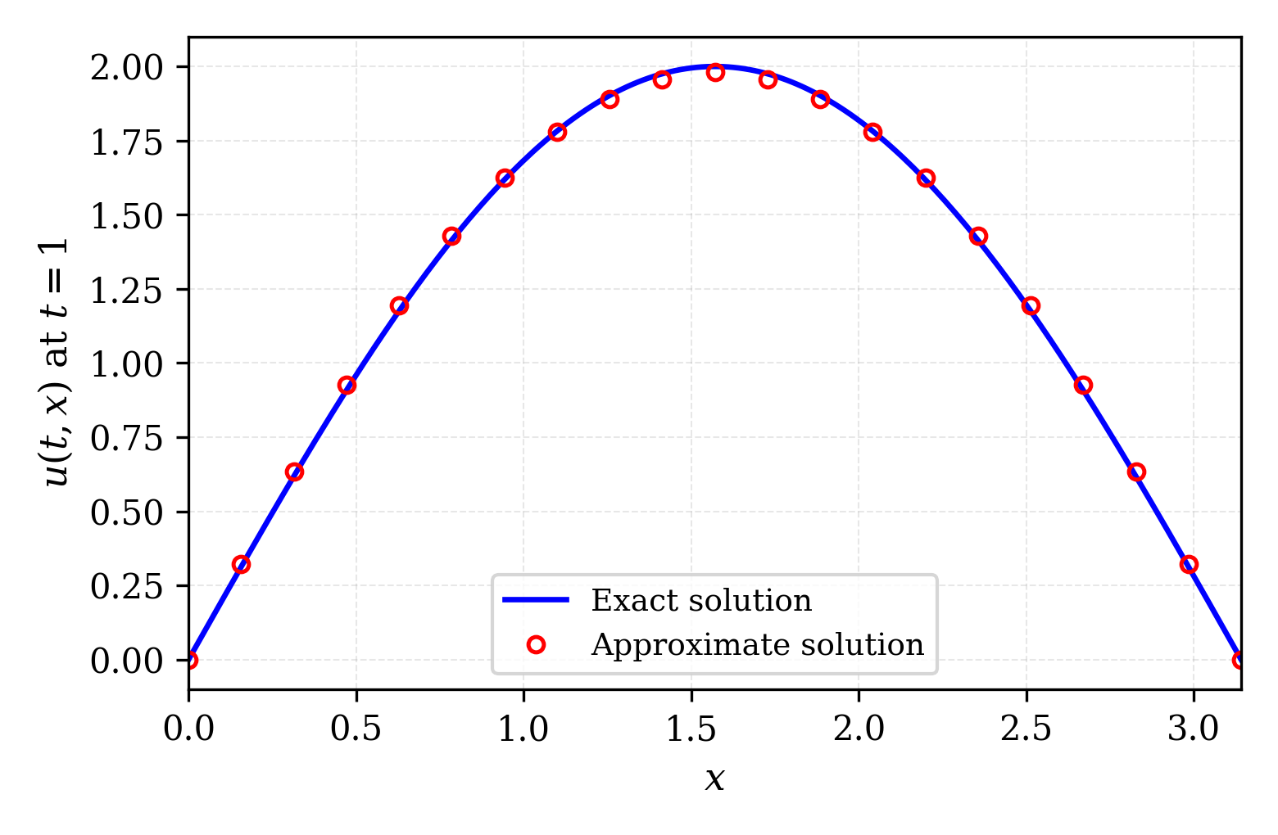
Figure 1. Comparison of the exact and approximate solutions of the model problem at t = 1.

5. Conclusion
The conclusion should summarize the main findings of the paper without repeating the abstract, emphasize the significance and novelty of the results, acknowledge any limitations, and indicate possible directions for future research.

Declarations
Acknowledgments: The authors thank ... (remove this section in the anonymized version submitted for review; include it in the separate title page file).
Funding: This research received no external funding. / This work was supported by [Funder], grant number [XXX].
Conflicts of interest: The authors declare that they have no known competing financial interests or personal relationships that could have appeared to influence the work reported in this paper.
Author contributions: Conceptualization, F.A.A.; methodology, F.A.A. and S.B.A.; software, S.B.A.; validation, T.C.A.; writing—original draft preparation, F.A.A.; writing—review and editing, all authors. All authors have read and agreed to the published version of the manuscript (CRediT taxonomy).
Data availability: The data and codes that support the findings of this study are available from the corresponding author upon reasonable request.
Use of AI tools: The authors declare that no generative AI tools were used in the preparation of this manuscript. / The authors used [tool] for [purpose]; the authors reviewed and edited the content and take full responsibility for the content of the publication.

References
[1] A. B. Author, C. D. Author, and E. F. Author, “Title of the journal article,” Journal Name, vol. 12, no. 3, pp. 123–145, 2025. https://doi.org/10.xxxx/xxxxx
[2] G. H. Author, Title of the Book, 2nd ed. City, Country: Publisher, 2023.
[3] I. J. Author and K. L. Author, “Title of the conference paper,” in Proceedings of the Conference Name, City, Country, 2024, pp. 55–62.
[4] M. N. Author, “Title of the thesis,” Ph.D. dissertation, Department, University, City, Country, 2022.
[5] O. P. Author, “Title of the preprint,” arXiv:2501.00000 [math.NA], 2025.
[6] Q. R. Author, “Title of the online resource,” Website Name, 2024. [Online]. Available: https://www.example.org (accessed DD Month 20XX).

Appendix A. Supplementary Material (Optional)
Appendices, if any, are placed after the references and labeled A, B, C, …. Equations in Appendix A are numbered (A.1), (A.2), …; tables and figures are numbered Table A.1, Figure A.1, and so on.

